1. Invoke the vi editor with a filename (which is to be created)

Command: $ vi <filename>



2. Type a few lines(at least 10) in the editor. Let one or more lines contain the words given below.

delhi mumbai chennai Mumbai

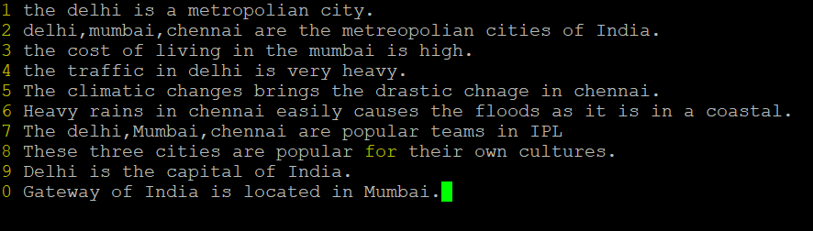

3. Save the file without exiting the editor

Enter in to the escape mode and give the command at the end of the file as :w.

4. Navigate quickly to the beginning & end of the file

This is done in the escape mode.

To navigate to beginning the file ---- gg

To navigate to end of the file --- shift + G

5. Delete first two lines & copy it after the last line.

Delete first two lines --- 2dd

Copy it after the last line --- p

6. Now Copy the last two lines & paste them before the first line.

Copy last two lines --- 2yy

paste them before the first line – go to beginning of line – gg then --- p.

7. Combine last two lines of the file in a single line.

To combine last two lines of the file in a single line --- J

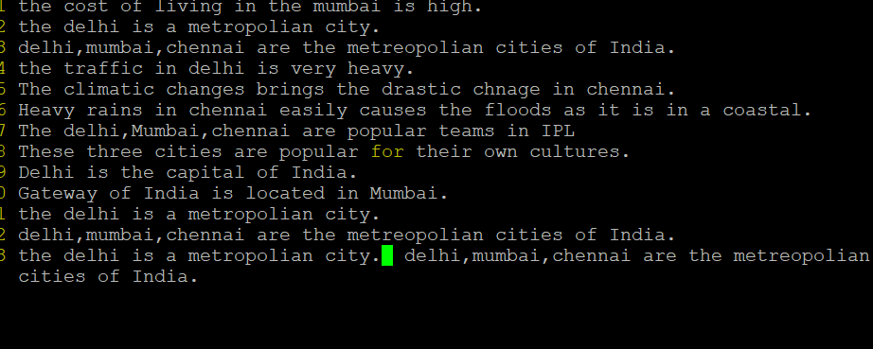

8. How will you insert a line before the first line? (Hint : Find such an option in the tutorial document)

A: To insert a line before the first line --- O

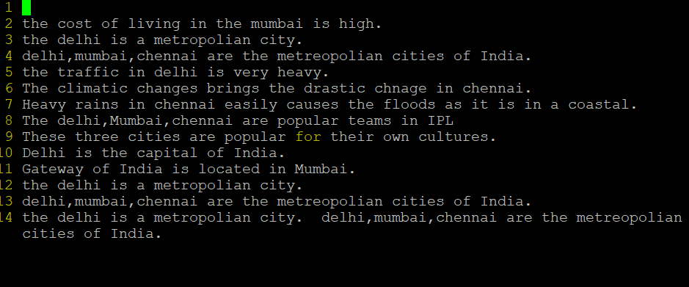

9. How will you paste a yanked buffer before the current line?

A: P is used to paste a yanked buffer .

10. Search the document for a string “delhi”

A: / delhi str

11. Replace a single occurrence of “delhi” with “Mumbai”

Command: :s/delhi/mumbai/



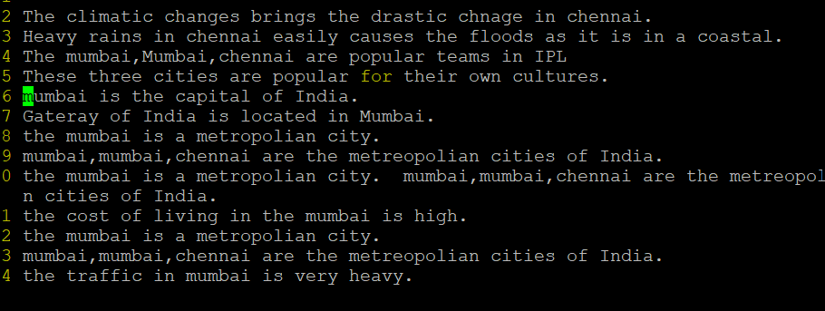

12. Replace all occurrences of “delhi” on a particular line with “Mumbai” using one command

Command: :8s/delhi/Mumbai/g

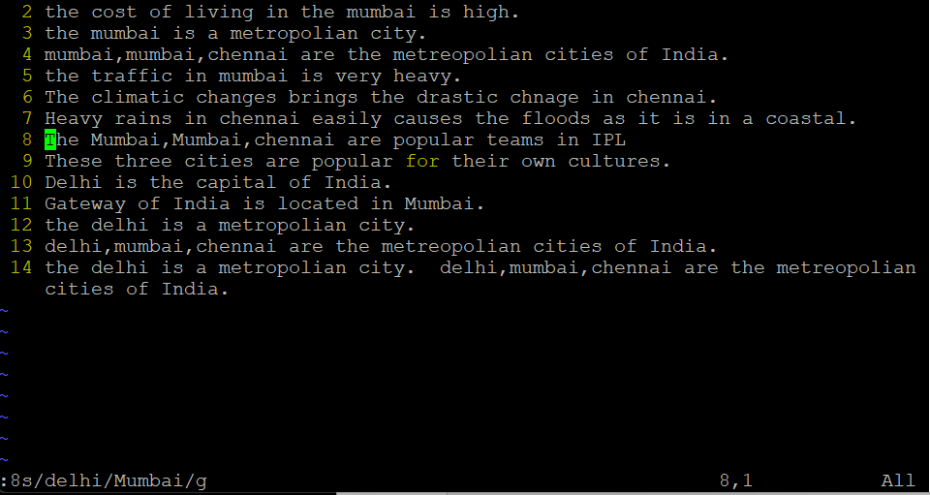

13. Replace “delhi” with “mumbai” for the entire document using one command.

Command: :1,$s/delhi/mumbai/g

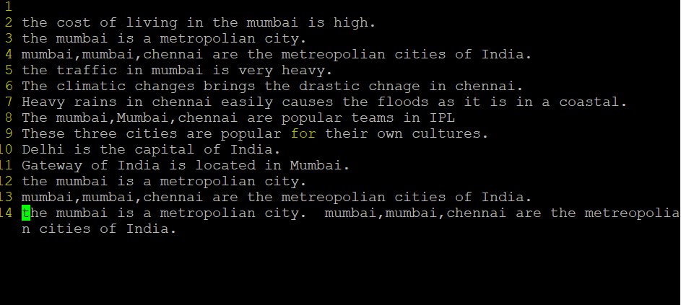

14. Replace all occurrences of “delhi” with “mumbai” for part of a document (e.g. line number 13 to 37).

Command : :2,10s/delhi/mumbai/g

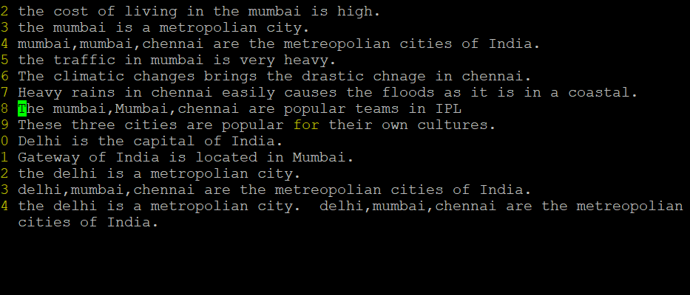

15. Undo the above command

command : u

16. Replace only the first occurrence of “delhi” with “mumbai” in each line, for part of a document (e.g. line number 13 to 37).

Command: :2,10s/delhi/mumbai/ --- in esc mode

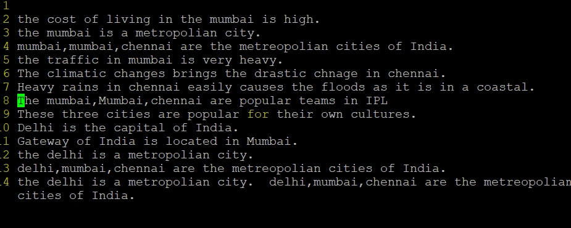

17. Undo the above comment. Redo it. Undo it again.

Command: u --- undo

Ctrl+r --- redo and again u to undo

18. Replace all occurrences of “delhi” with “mumbai” for complete file interactively.

Command: :%s/delhi/Mumbai/gc

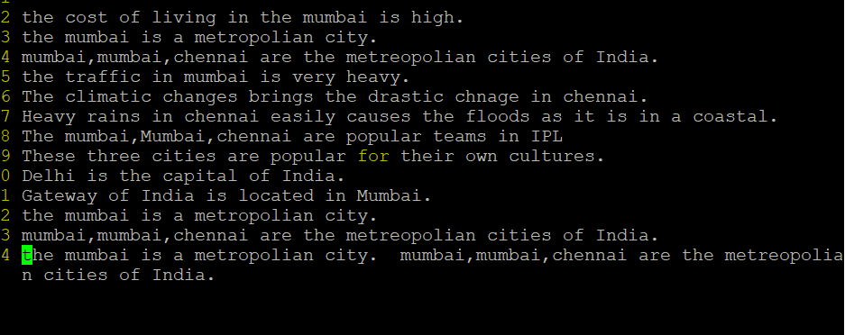

19. Search for a word backwards. Loop through all matches.

Command: Search for a word backwards ---- ?text

20. Search for a word forwards. Loop through all matches

Command: search for a word forwards ---- /text

21. Join two lines together.

Command : J

22. Enable line numbering and then disable it

Command: :set number

:set nonumber

23. Make the search case insensitive

Command: :set ignorecase

24. Delete 4 lines (and then paste them somewhere else)

Delete 4 lines ----- 4dd and the to paste –p

25. What is the command to delete part of the line starting from the current cursor

position?

Command : D

26. What is the command to delete the current word?

Command: dw